**Experiment 3**

**Maven Build using GitHub Actions**

**Aim**

Set up a GitHub Actions workflow to automatically build a Maven project whenever changes are pushed to a GitHub repository.

**Steps**

# 1. Create a maven project

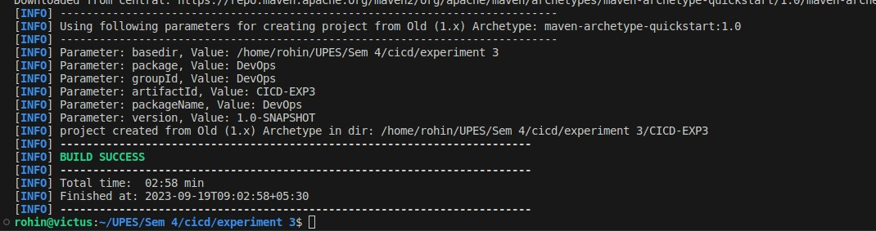

# 2. Create a Git Repository

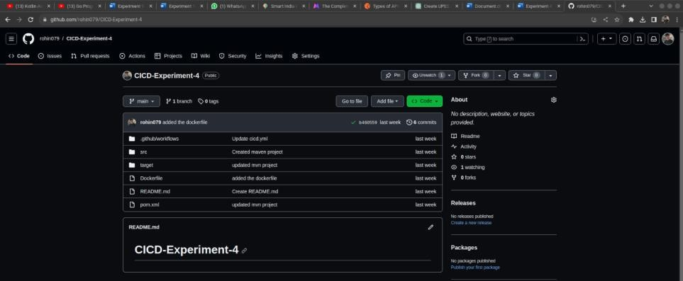

# 3. Commit and Push the changes on GitHub



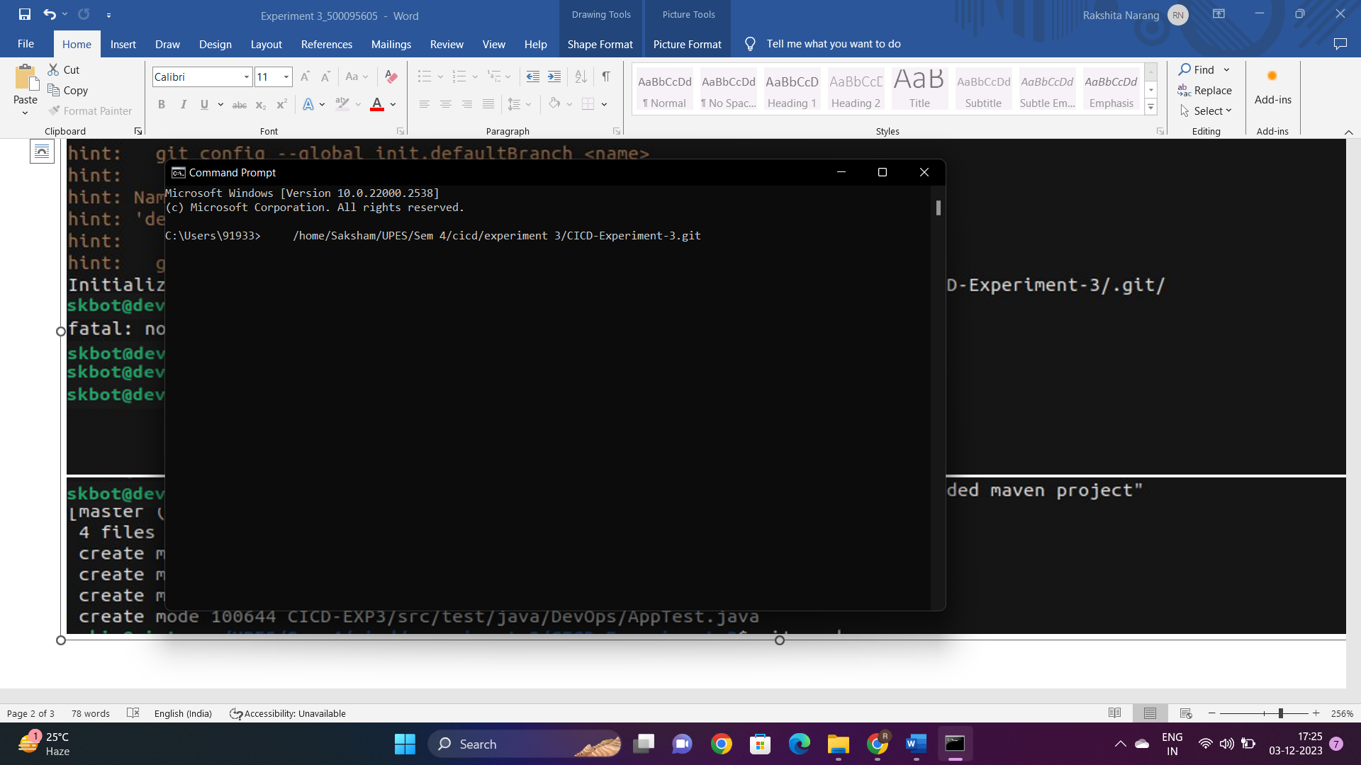

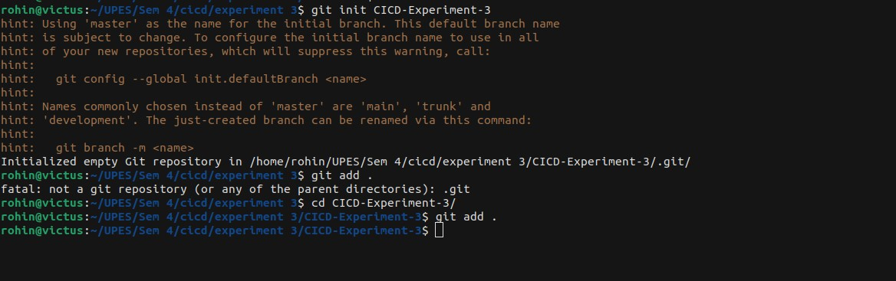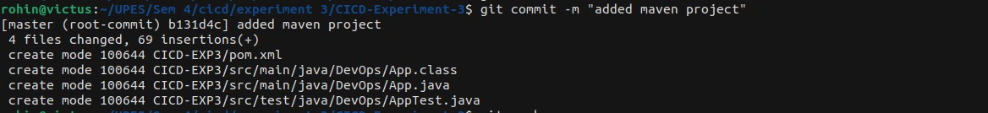

# 4. Setup GitHub workflow for the project

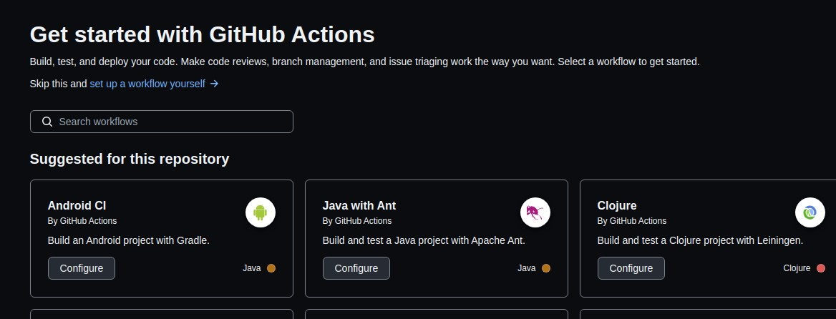

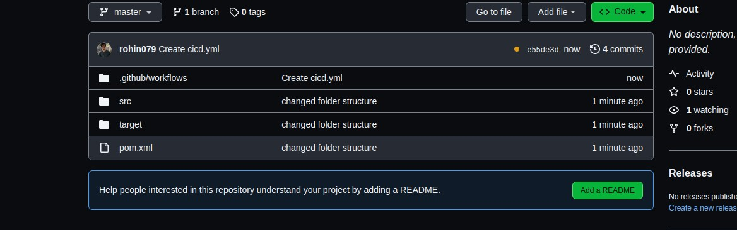

# 5. Configure the maven.yml file & commit the changes

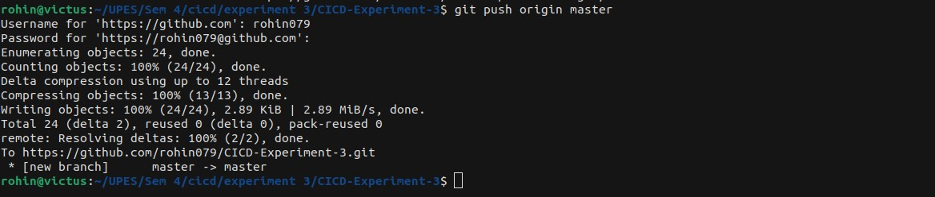

# 5. Pull the updated code on local machine 6. An automatic build will be triggered

